IB Math SL Notes Average Rate of Change/The Tangent Line
Topic 6 – Day 2

- Rates of Change:
Average Speed: _ ___________________________________________________________________

When plotted on a graph, distance is the ______ variable and time is the _____ variable.

Therefore, Average speed (Rate of change between distance and time) is defined as:

This is really the __________________________________________________________________

Average Velocity: ___________________________________________________________________

- A Bit of History:
As was mentioned last class, Calculus was developed to describe scientific ideas. Scientists, such as Sir Isaac Newton, wanted to figure out the instantaneous velocity of an object whose velocity was always changing. Such objects had non-linear graphs, and thus, finding a “slope”, or “gradient”, was not a straightforward task.

Information about the EPIC controversy between Isaac Newton and Gottfried Leibniz:
http://www.youtube.com/watch?v=axZTv5YJssA&feature=related
http://www.uh.edu/engines/epi1375.htm

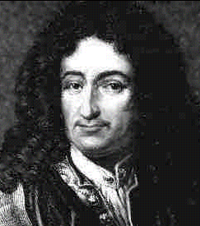
VS
Newton Leibniz
- The Secant Line
Consider the following curve:

The gradient of the secant line PQ is written as:

Ex: Write an expression for the gradient of the secant function for f(x) = 3x².

- The Tangent Line/Derivative
Consider what happens as we slide point Q closer to point P:

The gradient of the TANGENT line at point P is written as:

This is also known as the ________________________.

Notation for this is: _____ or ______.

Ex 2: Find the derivative of f(x) = 3x² and hence find the gradient of the tangent line when x = 4.

Ex 3: Find the derivative of f(x) = x + 7 and hence find the gradient of the tangent line when x = -2.

Ex 4: Find the derivative of f(x) = x² – 1 and hence find the gradient of the tangent line when x = 3.

