IB Math SL Conditional Probability
Unit 5 Notes – Day 3

- Conditional Probability
Suppose we have two events A and B, then:
“ A|B ” or “A/B” is the notation used to represent that “A occurs knowing that B has occurred.”

Ex: In a class of 25 students, 14 like pizza and 16 like coffee. One student likes neither and 6 students like both. One student is randomly selected from the class. What is the probability that the student:
- Likes pizza

- Likes pizza given that he/she likes coffee?

Ex 2: In a class of 40, 34 like bananas, 22 like pineapples, and 2 dislike both fruits - kinda like this teacher If a student is randomly selected, find the probability that the
student:

- Likes both fruits

- Likes at least one fruit

- Likes bananas given that he/she likes pineapples

- Dislikes pineapples given that he/she likes bananas

Conclusion:
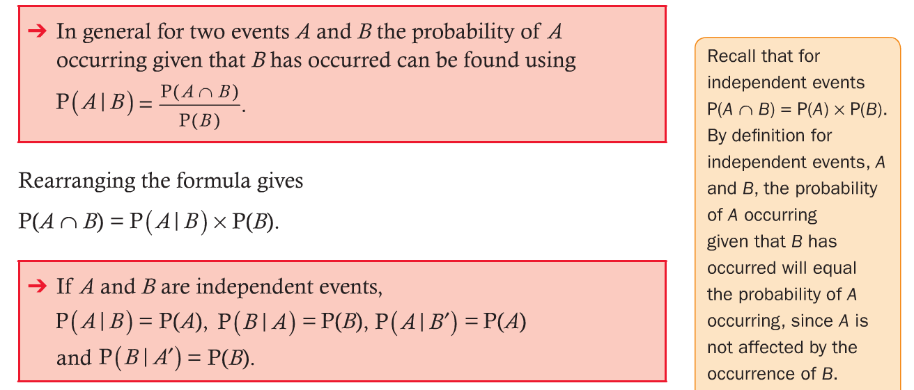
Ex 3: Given that $P\left(A\right)=\frac{2}{5}and P\left(A∩B\right)=\frac{1}{3}, find P\left(B | A\right). If P\left(A | B\right)=\frac{7}{8},find P\left(B\right).$

- Contingency Tables
Contingency tables are another tool useful in solving conditional probability problems.

Ex 4: At an IB school there are 3 IB Math courses. The Studies class contains 20 boys and 15 girls, the SL class contains 16 boys and 19 girls, and the HL class contains 4 girls and 6 boys.

- Make a table displaying the data. Include an additional row and column to display the total sum for each row and each column.

- Find the probability that a randomly selected male is taking Math Studies.

- Find the probability that a randomly selected HL student will be female.

- Probability Tree Diagrams
We have already mentioned the use of tree diagrams. This type of tree diagram displays the actual probability of each event occurring – you label the branch with each probability.

Successive Events: represented by adjoining branches. The probability is found by multiplying the probabilities of the successive events.

Alternative Events: represented by alternative branches. The probability is found by adding the probabilities of the alternative events.

Ex 5: A bag contains 3 red marbles and 2 yellow marbles. A marble is removed at random and not replaced. A second marble is removed at random. Find the probability that:
- The second marble is red, given the first is yellow.

- A red marble is taken on the second removal.

Ex 6: A coin is tossed and a die thrown. Find the probability that a head and a six are obtained.

Ex 7: Find the number of times a die needs to be thrown in order that there is a 90% chance a six is obtained.

Ex 8: In arms negotiations between two countries, it is estimated that there is a 50% chance that agreement will be reached on limiting chemical weapons and a 70% chance that agreement will be reached on limiting nuclear weapons. There is a 20% chance that no agreement will be reached on either issue. Find the probability of reaching agreement on both issues.

Ex 9: A pair of fair dice is thrown.
- Draw a tree diagram showing the probability of getting a four.

- Let E be the event that EXACTLY one four occurs when the pair of dice is thrown. Calculate P(E).

The pair of dice is thrown three times.
- Calculate the probability that event E occurs EXACTLY two times in the three throws.

- Calculate the probability that event E occurs AT LEAST two times in the three throws.

IB Math SL Topic 5, Part II Homework Name ___________________________________

