IB Math SL Measures of Spread
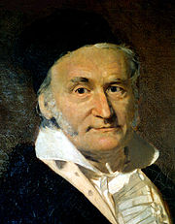
Notes – Unit 3, Day 4

- A bit of History:
In 1809 Gauss published his monograph "Theoria motus corporum coelestium in sectionibus conicis solem ambientium" where among other things he introduces several important statistical concepts, such as the method of least squares, the method of maximum likelihood, and the normal distribution.
http://en.wikipedia.org/wiki/Gaussian_distribution#History

- Analyzing Data:
There are a lot of factors to consider when analyzing data: mean, median, mode to name a few. You also want to consider the RANGE of the data.

In the following 2 data sets, find the mean and median:

- 31.3, 31.3, 31.5, 31.6, 31.7, 31.7, 32.1

$\overline{x}=$ _________ median = ___________

- 9.1, 10.3, 24.6, 31.6, 37.8, 47.9, 54.3

$\overline{x}=$ _________ median = ___________

What do you notice?
The data is very different, however!

- The Inter-Quartile Range:
The inter-quartile range is the “middle 50”. It is found by subtracting the lower quartile (Q_{L}) from the upper quartile (Q_{U}).

Inter-quartile range = Q_{U} - Q_{L}

Using the data sets a) and b) above, find the inter-quartile range (IQR) of each.

- Q_{U} = _______________ b) Q_{U} = __________________
Q_{L} = _______________ Q_{L} = _________________
IQR = _____________ IQR = _________________

- Box-and-Whisker Plot:
This is a visual way to represent the quartiles, median, highest point, and lowest point for a set of data. The box = inter-quartile range. The whiskers represent Q_{L} and Q_{U}.

Least Lower Median Upper Highest
Data Quartile Quartile Data
Point Point

Example: Use your GDC (steps below) to make a box-and-whiskers plot of the data shown:
17 | 13 | 18 | 11 | 21 | 17 | 14 | 18
19 | 15 | 15 | 26 | 19 | 18 | 14 | 14
13 | 20 | 18 | 16 | 15 | 19 | 17 | 13

To do in the GDC:
- Enter data into L₁
- 2nd STAT PLOT
- Choose the 2nd box-and-whiskers graphic.
- WINDOW
- Choose x-min and x-max to appropriately display the range of data
- Y-min = 0 and Ymax = 1
- GRAPH
- Use TRACE to find information about the quartiles, median, and extreme data points.

Examples:
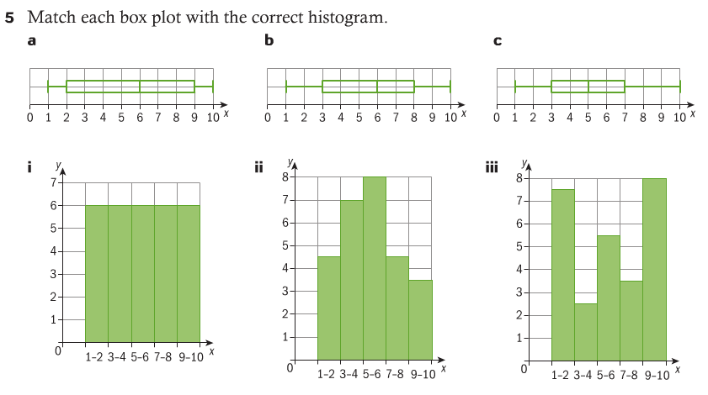
- The Standard Deviation:
The range of data and the IQR are good measures of spread, but we don’t use very many of the data points to calculate those measures.
Squaring the difference between each value and the mean is useful because:
- The differences will all be positive (thus they will not cancel each other out).
- Squaring gives more “weight” to data points that are further away from the mean.

f

Thankfully, this is another feature programmed into your GDC. The GDC uses the notation σ_{x} to denote the standard deviation of a set of data and s_{x} to denote an estimate of the standard deviation of a population from a sample. We will want the value for σ_{x.}

Example:
Grade, x_{i} | Frequency, f_{i}
1 | 0
2 | 2
3 | 10
4 | 13
5 | 10
6 | 8
7 | 6
Enter the frequency table for IB Math grades into L₁ and L₂ and use
1-Var Stats to find the standard deviation.

$o=$ _____________

This answer means that the majority of students are within that number of points of the mean.

SUMMARY:
IB Math SL Name ___________________________________________
Unit 3 HW – Day 4

(Do you use upper class boundaries or mid-class? Why?)

