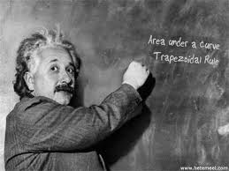IB Math SL **Definite Integrals (Continued)**

Topic 6, Part 2 – Day 5 Notes

1. **Area Under a Curve:**

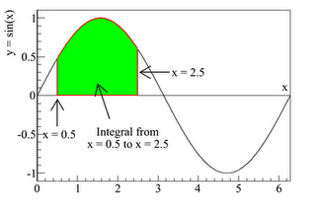**Ex:** Find 

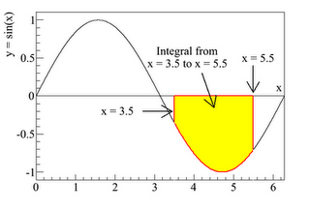**Ex 2:** Now, find .

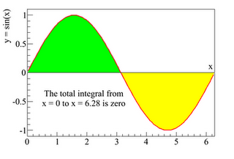

So what would happen if we found ?

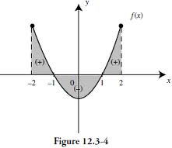**Conclusion:**

* If a problem asks for “net area”, they want you to keep the negative, so it will be possible to get an area of 0.
* If you are finding the total area, you will need to account for the negative area from the portion under the curve.

**Ex 3:** Consider the graph above of f(x) = x2 – 1.

1. Express the problem shown on the graph as an integral.
2. Find the total shaded area from -2 to 2.

**Ex 4:**  Find the total area bounded by the graph of f(x) = x(x – 2)(x – 3). Sketch a graph, express the problem in integral form, and solve.

**Ex 5:** Show that 

**Ex 6:** Find b correct to four decimal places: .

1. 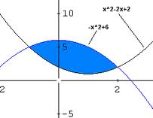**Area between two curves:**

Consider the situation shown. How can we find the area of the shaded region?

In general, this can be done by evaluating: 

(where f(x) is the “upper” function of the shaded region.)

**Ex 7:** Find the area of the shaded region in the previous picture.

**Ex 8:** Find the area bounded by the graphs of y = x + 2 and y = x2 + x – 2.

1. **Using your GDC to evaluate**

We can use the calculator to CHECK our answers, or to evaluate definite integrals for functions which we cannot anti-differentiate. The GDC can get a reasonable approximation.

**Ex 9:** Use your GDC to find the total area contained by f(x) = x3 + 2x2 – 3x and the x-axis.

Find zeros:

Look at or sketch a graph of f(x) so you know how to set up your integrals.

Total area will be found by evaluating the integrals:

Type into the GDC: fnInt(x3 + 2x2 – 3x, x, -3, 0) – fnInt(x3 + 2x2 – 3x, x, 0, 1)

**Ex 10:** Evaluate with your GDC: 