IB Math SL Notes **Instantaneous Rate of Change**

Topic 6 – Day 7

1. **Instantaneous Rates of Change:**

A moving object, like a car, a person running, an airplane, has variable speed throughout its movement.

At any particular instant, we can find the instantaneous speed of the object.

Instantaneous speed at a time, t, is:

**Ex 1:** The cost (in dollars) of producing *n* units of a product is modeled by the function

*C*(*n*) = 0.05*n*2 + 10*n* + 5000.

1. Find the average rate of change of C with respect to n when the production level changes from n = 100 units to n = 105 units.
2. Find the instantaneous rate of change of C with respect to n for any number of units n.
3. Find the instantaneous rate of change of C with respect to n when n = 100 units.

1. **Kinematics:**

Kinematics: The study of motion without regard to its cause. We will be discussing kinematics in one dimension (i.e. motion in a straight line).

f(x) = s(t) = position of an object with respect to time.

f'(x) = v(t) = instantaneous velocity (rate of change of position with respect to time)

f”(x) =a(t) = instantaneous acceleration (rate of change of velocity with respect to time)

If s(t) > 0, the object is moving ______________________

If v(t) > 0, the object is moving ______________________

**Ex 2:**  A particle moves in a straight line with a displacement of s meters t seconds after leaving a fixed point. The displacement function is given by: s(t) = 2t3 – 21t2 + 60t + 3, for t ≥ 0.

1. Find the velocity of the particle at any time t.
2. Find the initial position and the initial velocity of the particle.
3. Find when the particle is at rest.
4. Find when the particle is moving left and moving right.
5. Draw a motion diagram for the particle.

**Ex 3:** A particle moves vertically with displacement function s(t) = 56t – 6t2, t ≥ 0, where s is measured in meters and t in seconds. Find:

1. v(3), the velocity of the particle after three seconds.
2. When the particle is at rest.
3. The maximum height reached by the particle.

C:\Documents and Settings\afischer\Local Settings\Temporary Internet Files\Content.IE5\JIUVHTMQ\MC900441904[1].wmf

1. The acceleration of the particle.

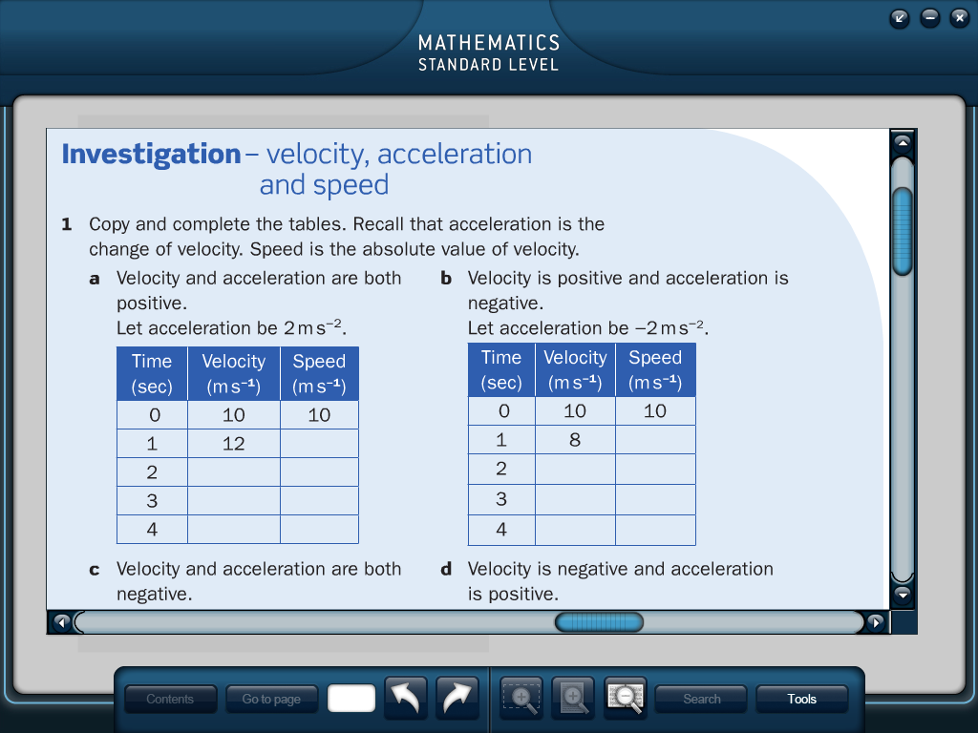

C:\Documents and Settings\afischer\Local Settings\Temporary Internet Files\Content.IE5\XWNGKX27\MC900139391[1].wmf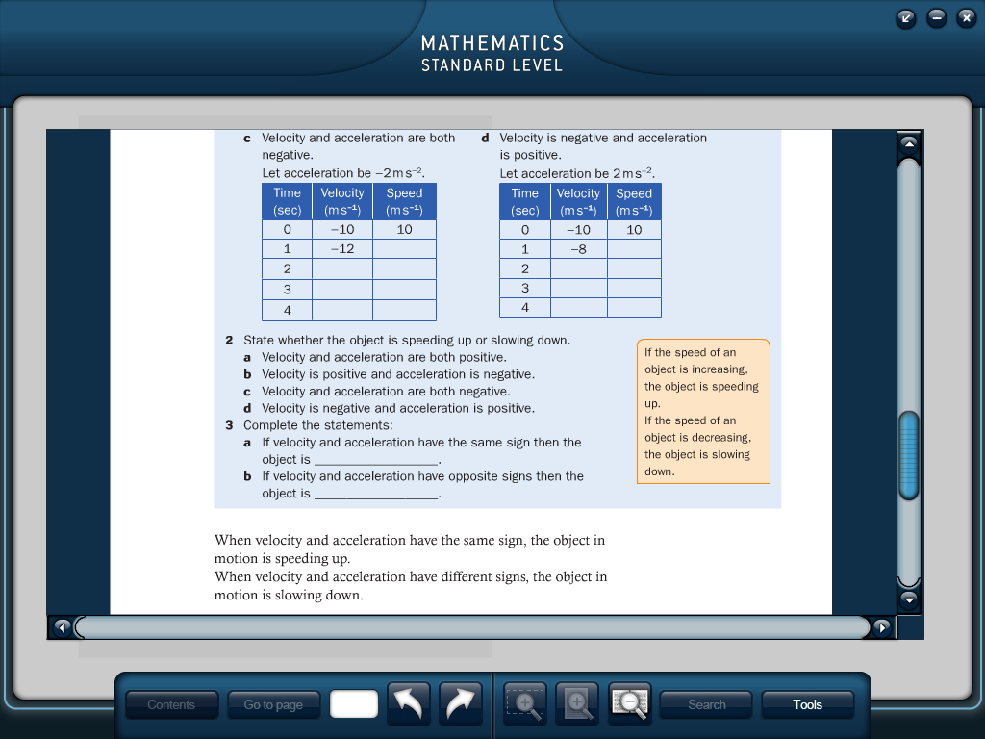

**Ex 4:** If y is the displacement of a particle which moves in a straight line relative to a fixed point, O, and y(t) = 4(1 – *e*-0.5t), t ≥ 0.

1. Find the distance of the particle from its starting position when t = 2.
2. Find v(t), the velocity of the function with respect to time.
3. Find the mean velocity during the first 2 seconds.
4. Find the acceleration of the particle when t = 5.

**Ex 5:** Determine if the particle with displacement function s(t) = 2t3 – 21t2 + 60t + 3 is speeding up or slowing down at t = 3 seconds.