IB Math SL Notes Review: Normal Distribution
Unit 5 – Day 9

- Standardized Normal Distribution:
We can collect data, plot it all in a histogram, and connect the tops of each bar together with a smooth curve. If the data is NORMALLY DISTRIBUTED, then the curve will represent a bell shape. We use this “bell curve” to represent the probability/percent of each outcome hence area under the curve must = 1.
History Tid-Bit:

Each bell curve approaches the x-axis asymptotically.
The graph of the normal distribution depends on two factors - the __________ and the ___________________________.
When the standard deviation is large, the curve is short and wide; when the standard deviation is small, the curve is tall and narrow. All normal distributions look like a symmetric, bell-shaped curve, as shown here: 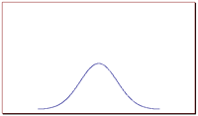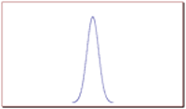
The curve on the left is shorter and wider than the curve on the right, because the curve on the left has a bigger standard deviation.

The most basic bell curve is given by$Z\sim N(0,1)$ and has the formula: .
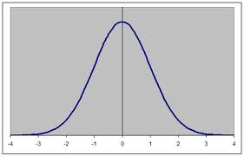
The following shows the % of data included within different standard deviations of the mean:
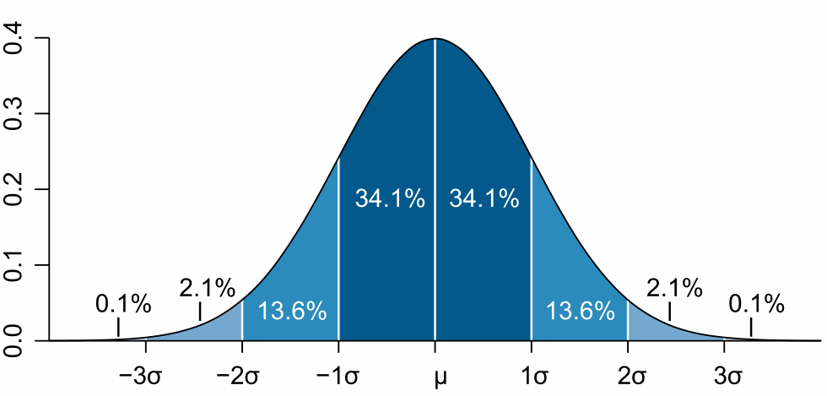

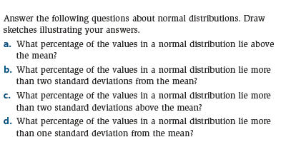

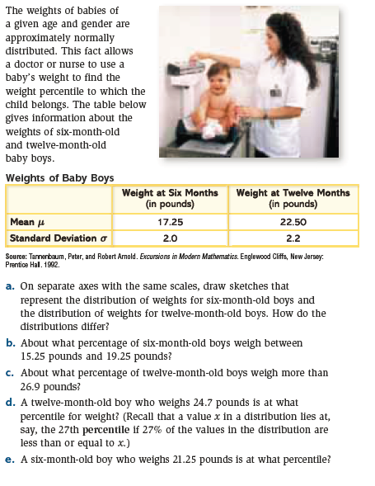

Let’s say you want to find the area to the left of the mark for 1σ on a standard normal distribution (meaning that the mean = 0 and the standard deviation = 1), we can use the GDC. The area is denoted by P(Z<1σ). In the GDC: 2nd VARS 2: normalcdf(

To find:
- P(z ≤ a) or P(z < a) use normalcdf (-(# bigger than 5), a)
- P(z ≥ a) or P(z > a) use normalcdf (a, # bigger than 5)
- P(a ≤ z ≤ b) or P(a < z < b) use normalcdf (a, b)

Examples:
- Find P(Z < -1.65) 2. Find P(Z > 0.72) 3. Find P(-0.4 < Z < 1.1)

4. Find P(Z > 0.34) 5. Find P(Z ≤ 3) 6. Find P(|Z| < 2.1)

- Normal Distribution in the GDC:

Examples (Note here the use of an X instead of a z):

Find the standardized value (z).
7. If X$\sim N(8,4)$, find P(X <9.5) 8. If X$\sim N(62,49)$, find P(X >54.3)

With our GDCs, it simply takes typing in a couple more numbers.

Type: normalcdf (#, #, μ, σ)

Examples (to be done with GDC):
- If $X\sim N(35,9)$, find P(X > 40) 10. If X$\sim N(62, 49)$, find P(58.5 ≤ X ≤ 71.8)

IB Math SL Unit 5– Day 9 HW Name ______________________________

