IB Math SL **Graphical Behavior**

Topic 6, Part I – Day 8 Notes

1. **A Bit of History**

The Cartesian Plane was named after Rene’ DesCartes (French: 1596-1650), but

did you know that he only used positive x and y coordinates? Guess who

introduced the negative coordinates? _____________________

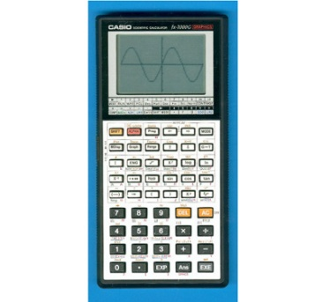

Did you know: The first graphing calculator was introduced in *1985* by

Casio. Can you imagine how outraged teachers must have been?

So before we could look at a graph in two seconds, we had to actually

DO MATH to know what graphs look like. This math involves CALCULUS and

you will be asked to do some on Paper 1 (no GDC)!

1. **Increasing/Decreasing:**

Consider the following graphs and their intervals of increasing and decreasing:

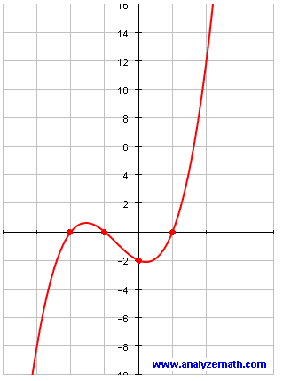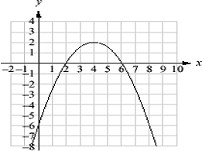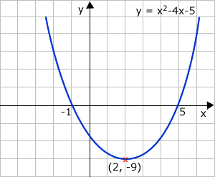

How do you think the derivatives of these functions might relate to increasing/decreasing?

What happens when f’(x) = 0?

Conclusion:

**Ex 1:** Find the extrema, hence the intervals of increasing/decreasing for the function 

**Ex 2:** Find the extrema, hence the intervals of increasing/decreasing for the function 

**Ex 3:** Find the extrema, hence the intervals of increasing/decreasing for the function 

1. **Concavity:**

Concave Down: Concave Up:

So, on a nice graph, this is really easy to determine visually. Not so much with crazy graphs.

**Ex 4:** Consider f(x) = x2.

Find the derivative and evaluate at x = {-2, -1, 0, 1, 2}. Sketch a graph of the derivative.

Now find(which means we are finding the slope of the tangent line to the graph of ).

Conclusion: When a graph is concave up, *f”(x)* > 0.

Likewise, when a graph is concave down, *f”(x)* < 0.

**Ex 5:** Consider the graph shown. Using the terms y

>0, <0, or = 0, make a true statement about: y = *f(x)*

a) *f(a)* P(a, f(a))

b) *f’(a)*

c) *f”(a)* O x

**Ex 6:** Consider the graph shown. Using the terms y

>0, <0, or = 0, make a true statement about:

a) *f(a)* P(a, f(a))

b) *f’(a)*  x

c) *f”(a)* O y = *f(x)*

In the following graph, the concavity changes. Where does it change? How can we determine those points on a graph? Answer: With Calculus.

1. **Extrema and Points of Inflection:**

When *f”(x)* = 0, there exists either an extreme (a max/min) or a point of inflection. (Again, this is easy to see on a polynomial graph). A point of inflection will occur as the graph changes concavity.

Notice, at the points of inflection, a tangent line will cross through the graph. If the slope of the tangent line (f’(x)) = 0, the point of inflection is called a _______________________________________________.

A maximum will occur if: _________________________________________________________________

______________________________________________________________________________________

A minimum will occur if: __________________________________________________________________

______________________________________________________________________________________

For the following, find and classify all extrema and points of inflection without your GDC.

**Ex 7:** f(x) = x3 – 3x2 + 9

**Ex 8:** f(x) = x4 – 4x3 + 5

**Summary:**

Consider a moving object.

* *f(x)* determines the *POSITION* of the object with respect to time.
* *f’(x)* determines *INSTANTANEOUS VELOCITY* with respect to time.

Finding whether *f’(x)* is pos/neg/ = 0 helps you determine inc/dec/max/min.

* *f”(x)* determines *INSTANTANEOUS ACCELERATION* with respect to time.

Finding whether *f”(x)* is pos/neg/=0 helps you determine inflection points and concavity.

**Ex 9:** 

1. Find the derivative of *f*.
2. Solve the equation *f*’(x) = 0. Hence find the value of *f* where there is a turning point.
3. Explain why this point is a minimum value as opposed to a maximum.

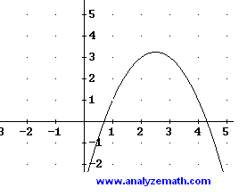**Ex 10:**

1. Given that the graph shown is f, sketch the graphs of

f’ and f’’.



1. Given that the graph shown is f’, sketch the graphs of f

and f’’.