IB SL Year 1 Exam Review - May 21, 2016 Name ___________________________

- Let be a quadratic function. Part of the graph of is shown below. The vertex is at P(, ) and the y-intercept is at Q(, ) .
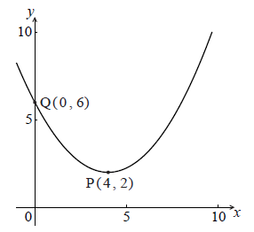
- Write down the equation of the axis of symmetry. (1)
The function f can be written in the form 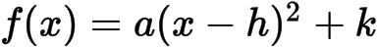 .
b. Write down the value of h and of k. (2)
c. Find a. (3)
Working:

Answers:
(a)…......................................................................
(b)…......................................................................
(c)…......................................................................
(Total 6 marks)
- Let 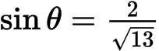 , where 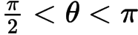 .
a. Find . (3)
b. Find . (5)
Working:

Answers:
(a)…......................................................................
(b)…......................................................................
(Total 8 marks)
3. Let 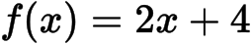 and 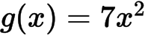 .
a. Find 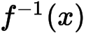 . (3)
b. Find 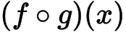 . (2)
c. Find 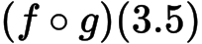 . (2)
Working:

Answers:
(a)…......................................................................
(b)…......................................................................
(c)…......................................................................
(Total 7 marks)
4. Consider the following circle with centre O and radius 6.8 cm. The length of the arc PQR is 8.5 cm.
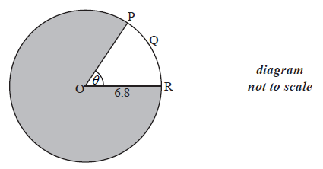
a. Find the value of . (2)
b. Find the area of the shaded region. (4)
Working:

Answers:
(a)…......................................................................
(b)…......................................................................
(Total 6 marks)
5. Consider the triangle ABC, where AB =10 , BC = 7 and = 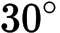 .
a. Find the two possible values of . (4)
b. Hence, find 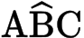 , given that it is acute. (2)
Working:

Answers:
(a)…......................................................................
(b)…......................................................................
(Total 6 marks)
6. Consider the expansion of 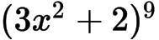 .
a. Write down the number of terms in the expansion. (1)
b. Find the term in 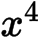. (5)
Working:

Answers:
(a)…......................................................................
(b)…......................................................................
(Total 6 marks)
7. Jose takes medication. After t minutes, the concentration of medication left in his bloodstream is given by 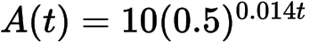 , where A is in milligrams per litre.
a. Write down 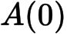 . (1)
b. Find the concentration of medication left in his bloodstream after 50 minutes. (2)
c. At 13:00, when there is no medication in Jose’s bloodstream, he takes his first dose of medication. He can take his medication again when the concentration of medication reaches 0.395 milligrams per litre. What time will Jose be able to take his medication again? (5)
Working:

Answers:
(a)…......................................................................
(b)…......................................................................
(c)…......................................................................
(Total 8 marks)
8. The quadratic equation 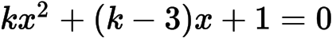 has two equal real roots.
a. Find the possible values of k. (5)
b. Write down the values of k for which 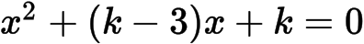 has two equal real roots. (2)
Working:

Answers:
(a)…......................................................................
(b)…......................................................................
(Total 7 marks)
9.a. Consider an infinite geometric sequence with 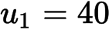 and 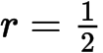 .
(i) Find .

(ii) Find the sum of the infinite sequence. (4)

b. Consider an arithmetic sequence with n terms, with first term (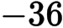) and eighth term (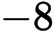).
(i) Find the common difference.

(ii) Show that 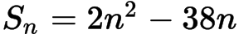 . (5)

The sum of the infinite geometric sequence is equal to twice the sum of the arithmetic sequence.
c. Find n. (5)

(Total 15 marks)
10. Let , for 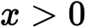 .
a. Show that 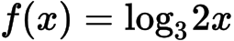 . (2)

b. Find the value of 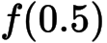 and of 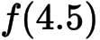 . (3)

c. The function f can also be written in the form 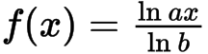 .
(i) Write down the value of a and of b .

(ii) Hence on graph paper, sketch the graph of f , for 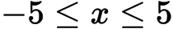 , 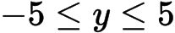 , using a scale of 1 cm to 1 unit on each axis.

(iii) Write down the equation of the asymptote.
(6)
d. Write down the value of 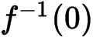 . (1)
e. The point A lies on the graph of f . At A, 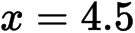 . On your diagram, sketch the graph of 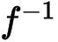 , noting clearly the image of point A. (4)
(Total 16 marks)
11. Let 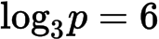 and 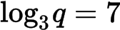 .
a.(i) Find 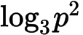 .

(ii) Find 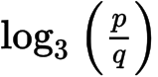 .

(iii) Find 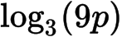 . (7)

b. Find . (2)

c. Find . (2)

d. Find . (3)

(Total 14 marks)
12. Let 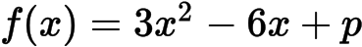. The equation 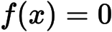 has two equal roots.
a. Write down the value of the discriminant. (1)

b. Hence, show that 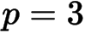. (2)

The graph of has its vertex on the -axis.
c. Find the coordinates of the vertex of the graph of . (4)

d. Write down the solution of . (1)

The function can be written in the form 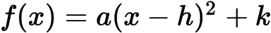 and has its vertex on the x-axis.
e. Write down the value of . (1)

f. Write down the value of . (1)

g. Write down the value of . (1)

h. The graph of a function is obtained from the graph of by a reflection of in the -axis, followed by a translation by the vector 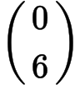. Find , giving your answer in the form 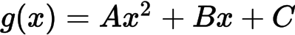. (4)

(Total 15 marks)

