**PreCalculus: Unit 4 – beginning trigonometry**

Trigon: Metron:

1. **Reviewing Sine and Cosine Graphs**

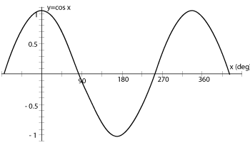

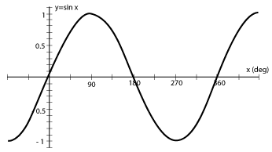

Use your knowledge of ***basic transformations*** to graph the following (LABEL THE AXES appropriately):

1. [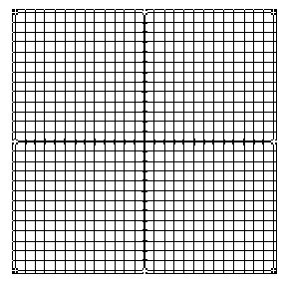](http://sites.google.com/a/rism.ac.th/ms-jennys-accelerated-9/Home/blank-coordinate-plane/blankgrid.gif?attredirects=0)  2) 
2. [](http://sites.google.com/a/rism.ac.th/ms-jennys-accelerated-9/Home/blank-coordinate-plane/blankgrid.gif?attredirects=0) 4) 

[](http://sites.google.com/a/rism.ac.th/ms-jennys-accelerated-9/Home/blank-coordinate-plane/blankgrid.gif?attredirects=0) 5)  6) 

1. **Review of the Unit Circle**

Last year, we explored the idea of finding heights and distances along the edge of a Ferris Wheel and looked specifically at a wheel with a radius of 1. We found out that when the radius = 1:

sine represents ____________________________________. cosine represents __________________________________.

If we were to plot the Ferris Wheel on a set of x- and y- axes, we would know all of the coordinates of the points shown. Fill in all degree values, radian values, heights, and displacements:



**\*\* The values for Quadrant I need to be committed to memory (for life… not crammed). There will be multiple quizzes on this beginning next class.**

**Recall SohCahToa?**

|  |  |
| --- | --- |
| $\sin{θ= \frac{ }{ }}$ | hypotenuse  opposite |
| $\cos{θ}{= \frac{ }{ }}$ | **θ**    adjacent |
| $\tan{θ}{= \frac{ }{ }}$ |  |

Ex) What is $\frac{\sin{θ}}{\cos{θ}}$?

1. **Review Use of the Unit Circle information:**

We can answer questions, giving EXACT (non-decimal) values, for questions involving the angles listed on the unit circle.

**Ex:** find the exact value of (sin 45°)(cos 60°).

**Ex 2:** Find the exact value of tan 60°.

**You try:** *(You will ultimately need to do this on the test WITHOUT being given the circle and WITHOUT a calculator, so you should figure out a method for approaching the problems without any resources!)*

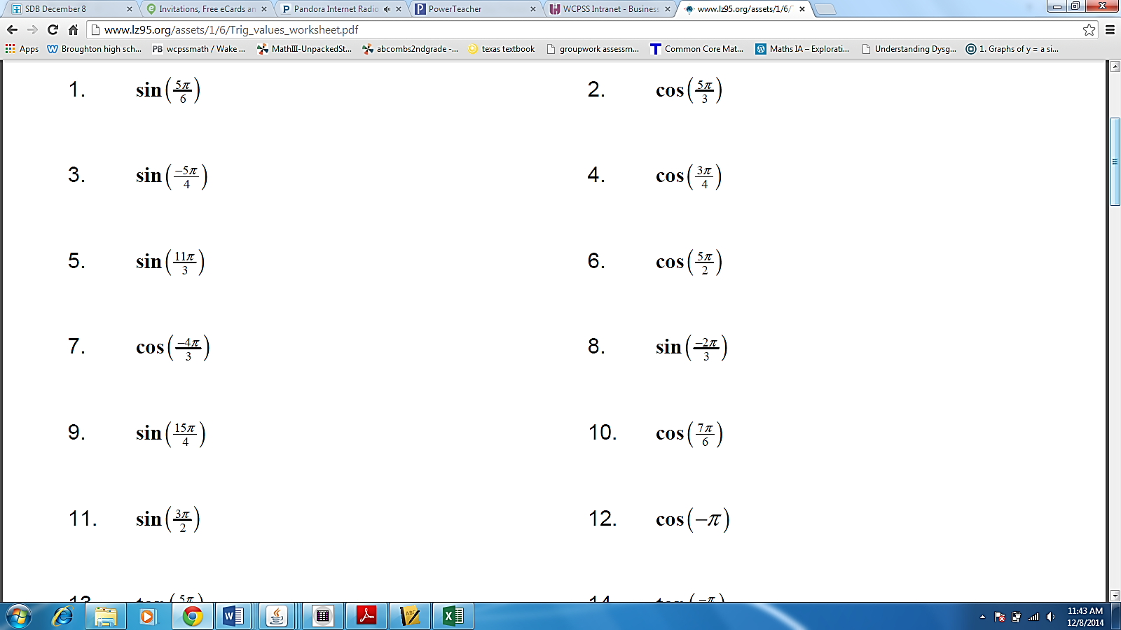

1. 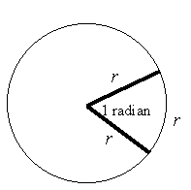**Arc Length Review**

Recall: A central angle measures 1 Radian when the arc length = the radius.

So what changes if the arc length is 0.5*r*? Or 2*r*?

Write a formula for arc length using *s* for arc length, ɵ for the radian measure

of the angle, and *r* for radius.

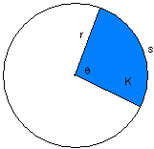

Suppose you are trying to find the area of the sector (shaded region).

$θ=\frac{5π}{8}$ and $r=4$. Find the area, leaving your answer exact.

Explore using other values for theta and r, leaving your answer for area exact. For example, what changes if $θ=\frac{π}{2}?$ What if r = 8? Take your findings and develop an area formula for sectors.

1. **Unit Conversion Review**

How did we convert between degrees and radians?

Ex: Convert $\frac{6π}{7}$ to degrees.

Ex 2: Convert 2.5 radians to degrees.

Ex 3: Convert 67° to radians.

Ex 4: Convert 195° to radians.

**This is Day 3**

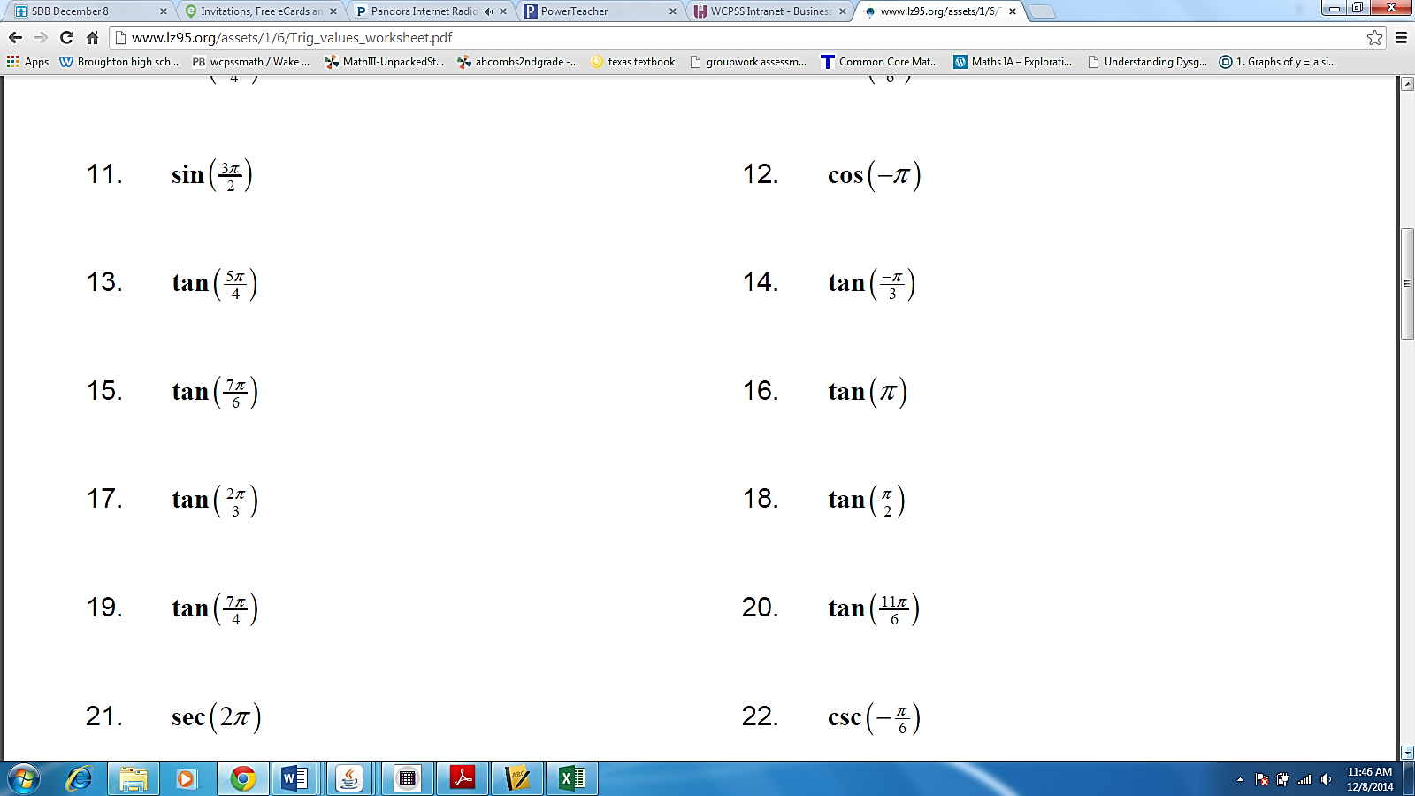

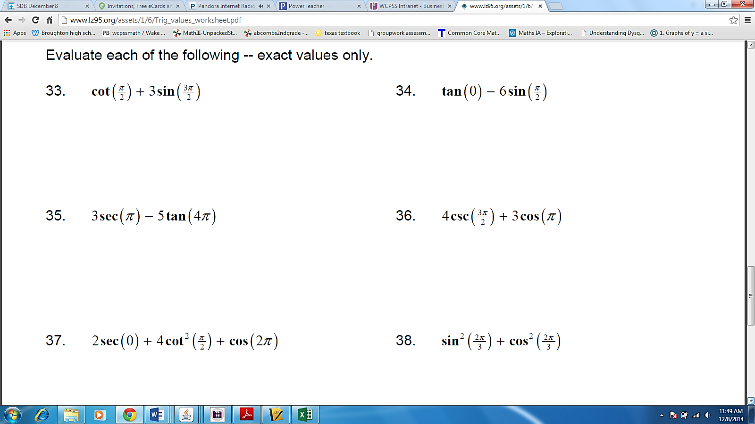



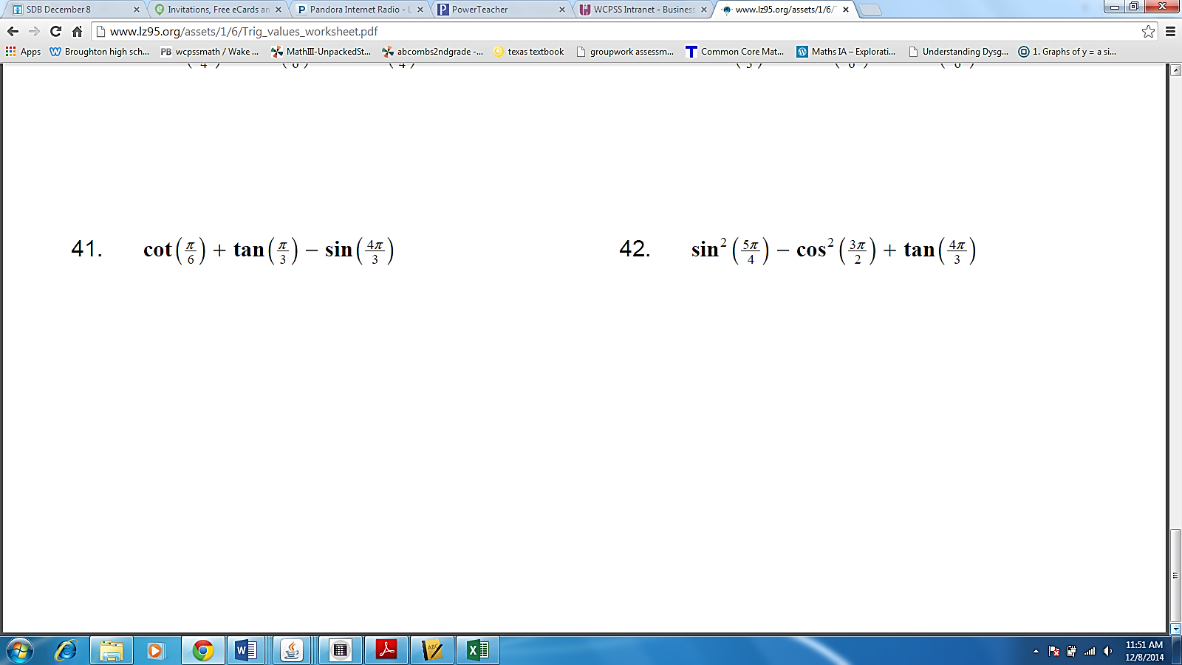

**This is Day 4**

1. **Other Types:**

We can also use this “circular” idea to solve some other types of problems.

|  |  |
| --- | --- |
| $$\sin{θ= \frac{ }{ }}$$ |  |
| $$\cos{θ}{= \frac{ }{ }}$$ |  |
| $$\tan{θ}{= \frac{ }{ }}$$ |  |

**Ex:** An angle, we’ll call it ɵ, has a terminal side that passes through the point (3, 2). Find the three trig ratios for this angle.

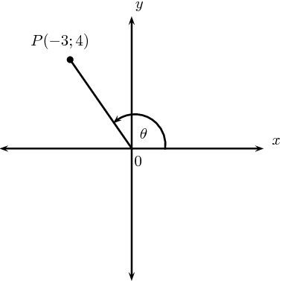**Ex 2:** Find the three trig values. Sidebar: How *would* you find theta?

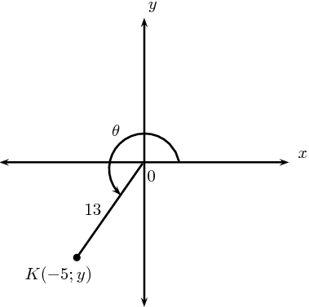**Ex 3:** Find the value of *y*.