PreCalculus - NOTES
5.5 The Law of Sines

For any triangle (right, acute or obtuse), you may use the following formula to solve for missing sides or angles:

Use the Law of Sines when…you have 3 dimensions of a triangle and you need to find the other 3 dimensions - they cannot be just ANY 3 dimensions though, or you won’t have enough info to solve the Law of Sines equation. Use the Law of Sines if you are given:

Example 1
You are given a triangle, ABC, with angle A = 70°, angle B = 80° and side a = 12 cm. Find the measures of angle C and sides b and c.

Example 2
You are given a triangle, ABC, with angle C = 115°, angle B = 30° and side a = 30 cm. Find the measures of angle A and sides b and c.

The Ambiguous Case

When given SSA (two sides and an angle that is NOT the included angle) , the situation is ambiguous. The dimensions may not form a triangle, or there may be 1 or 2 triangles with the given dimensions. We first go through a series of tests to determine how many (if any) solutions exist.

If angle A is obtuse…

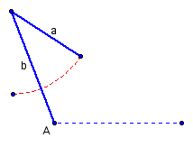
- If angle A is obtuse, and a < b or a = b, no such triangle exists.

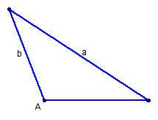
- If angle A is obtuse, and a > b, one such triangle exists.

Ex I) Given a triangle with angle A = 120°, side
a = 22 cm and side b = 15 cm,
find the other dimensions.

If angle A is acute…

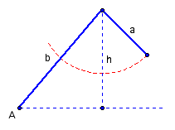
- If angle A is acute, and a < h, no such triangle exists.

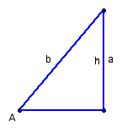
- If angle A is acute, and a = h, one possible triangle exists.
Angle B is a right angle.

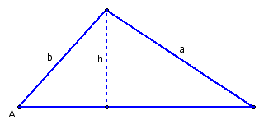
- If angle A is acute, and a > b, one possible triangle exists.

Ex II-2) Given a triangle with angle A = 40°,
side a = 12 cm and side b = 10 cm,
find the other dimensions.

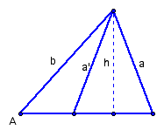
- If angle A is acute, and h < a < b, two possible triangles exist.

Ex II-1)Given a triangle with angle A = 40°,
side a = 12 cm and side b = 15 cm,
find the other dimensions.

SSA Summary:

Ambiguous Examples:

- Given: A = 130°, c = 9, a = 12… Find: B, C, b

- Given: B = 90°, C = 30°, c = 2… Find: A, a, b

- Given: A = 65°, a = 6, c = 8… Find: B, C, b

Example 3
Two observers are 600 ft apart on opposite sides of a flagpole. The angles of elevation from the observers to the top of the pole are 19⁰ and 21⁰. Find the height of the flagpole.

Example 4
Officer Chamblee at checkpoint A notices 2 wrecked cars in the direction 48⁰ east of north. Officer Thorne at checkpoint B, 12 miles due east of A, spots the same accident 30⁰ west of north. Find the distance from each checkpoint to the accident.

