**IB Math SL Name ________________________**

**Topic 6, Part I Review Date ________________________**

**You should be able to:**

* Construct frequency and cumulative frequency tables
* Construct and interpret histograms, box and whisker plots, and cumulative freq graphs
* Calculate mean, median, mode, standard dev., quartiles

**Practice Problems**

**1.** At a conference of 100 mathematicians there are 72 men and 28 women. The men have a mean height of 1.79 m and the women have a mean height of 1.62 m. Find the mean height of the 100 mathematicians.

|  |  |
| --- | --- |
| *Working:* |  |
|  | *Answer:*  ...................................................................... |

(Total 4 marks)

**2.** The mean of the population *x*1, *x*2, ........ , *x*25 is *m*. Given that = 300 and  
 = 625, find

(a) the value of *m*;

(b) the standard deviation of the population.

|  |  |
| --- | --- |
| *Working:* |  |
|  | *Answers*:  (a) ..................................................................  (b) .................................................................. |

(Total 4 marks)

**3.** A supermarket records the amount of money *d* spent by customers in their store during a busy period. The results are as follows:

|  |  |  |  |  |  |  |  |
| --- | --- | --- | --- | --- | --- | --- | --- |
| Money in $ (*d*) | 0–20 | 20–40 | 40–60 | 60–80 | 80–100 | 100–120 | 120–140 |
| Number of customers (*n*) | 24 | 16 | 22 | 40 | 18 | 10 | 4 |

(a) Find an estimate for the mean amount of money spent by the customers, giving your answer to the nearest dollar ($).

(2)

(b) Complete the following cumulative frequency table and use it to draw a cumulative frequency graph. Use a scale of 2 cm to represent $20 on the horizontal axis, and 2 cm to represent 20 customers on the vertical axis.

(5)

|  |  |  |  |  |  |  |  |
| --- | --- | --- | --- | --- | --- | --- | --- |
| Money in $ (*d*) | <20 | <40 | <60 | <80 | < 100 | < 120 | < 140 |
| Number of customers (*n*) | 24 | 40 |  |  |  |  |  |

(see next page for graph)

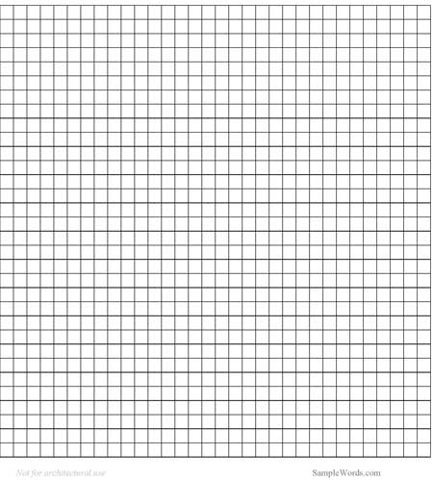

(c) The time *t* (minutes), spent by customers in the store may be represented by the equation

*t* = ** + 3.

1. Use this equation and your answer to part (a) to estimate the mean time in minutes spent by customers in the store.

(3)

(ii) Use the equation and the cumulative frequency graph to estimate the number of customers who spent more than 37 minutes in the store.

(5)

(Total 15 marks)

**4.** In a suburb of a large city, 100 houses were sold in a three-month period. The following **cumulative frequency table** shows the distribution of selling prices (in thousands of dollars).

|  |  |  |  |  |  |
| --- | --- | --- | --- | --- | --- |
| Selling price *P* ($1000) | *P*  100 | *P*  200 | *P*  300 | P  400 | P  500 |
| Total number of houses | 12 | 58 | 87 | 94 | 100 |

(a) Represent this information on a cumulative frequency **curve**, using a scale of 1 cm to represent $50000 on the horizontal axis and 1 cm to represent 5 houses on the vertical axis.

(4)



(b) Use your curve to find the interquartile range.

(3)

The information above is represented in the following frequency distribution.

|  |  |  |  |  |  |
| --- | --- | --- | --- | --- | --- |
| Selling price *P* ($1000) | 0 < *P*  100 | 100 < *P*  200 | 200 < *P*  300 | 300 < *P*  400 | 400 < *P*  500 |
| Number of houses | 12 | 46 | 29 | *a* | *b* |

(c) Find the value of *a* and of *b*.

(2)

(d) Use mid-interval values to calculate an estimate for the mean selling price.

(2)

(e) Houses which sell for more than $350000 are described as *De Luxe*.

(i) Use your graph to estimate the number of *De Luxe* houses sold.  
Give your answer to the nearest integer.

(ii) Two *De Luxe* houses are selected at random. Find the probability  
that **both** have a selling price of more than $400000.

(4)

(Total 15 marks)

**5.** A student measured the diameters of 80 snail shells. His results are shown in the following cumulative frequency graph. The lower quartile (LQ) is 14 mm and is marked clearly on the graph.



(a) On the graph, mark clearly in the same way and write down the value of

(i) the median;

(ii) the upper quartile.

(b) Write down the interquartile range.

|  |  |
| --- | --- |
| *Working:* |  |
|  | *Answer*:  (b) .................................................................. |

(Total 6 marks)

**6.** Let *a*, *b*, *c* and *d* be integers such that *a* < *b*, *b* < *c* and *c* = *d*.

The mode of these four numbers is 11.  
The range of these four numbers is 8.  
The mean of these four numbers is 8.

Calculate the value of each of the integers *a*, *b*, *c*, *d*.

|  |  |
| --- | --- |
| *Working:* |  |
|  | *Answers*:  *a* = ............................., *b* = .............................  *c* = ............................., *d* = ............................. |

(Total 6 marks)

**7.** The box and whisker diagram shown below represents the marks received by 32 students.

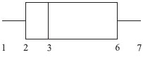

(a) Write down the value of the median mark.

(b) Write down the value of the upper quartile.

(c) Estimate the number of students who received a mark greater than 6.

..............................................................................................................................................

..............................................................................................................................................

..............................................................................................................................................

..............................................................................................................................................

..............................................................................................................................................

(Total 6 marks)

**8.** The four populations A, B, C and D are the same size and have the same range.

Frequency histograms for the four populations are given below.

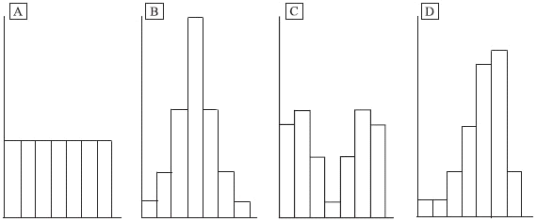

(a) Each of the three box and whisker plots below corresponds to one of the four populations. Write the letter of the correct population under each plot.



(b) Each of the three cumulative frequency diagrams below corresponds to one of the four populations. Write the letter of the correct population under each diagram.

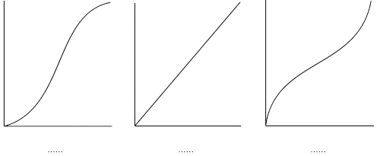

(Total 6 marks)